1) My Target:

---------------------

I'm Md Arfan Khan, A Front End Reacj Js Developer. Currently I'm learning react Js. I love to work with Javascript programming language. In my next two upcoming years I want to be a good Mern Stack Web Developer. As it has a very good demand now a days. Day by Day Its popularity is increasing. After begin a good Mern developer I would like to share my development skills with others without any cost. And I want to make our country without any unemployment person. This is my Goal.

2)Forean Country's Job Site Link –

--------------------------------------------------------------------------------------

1)Indeed :

<https://www.indeed.com/m/>

Job Link:

https://www.indeed.com/viewjob?jk=ef9fc487853df3c6&tk=1g5c2u3lph0lv800&from=serp&vjs=3

2)Glassdore :

<https://www.glassdoor.com>

3)GetWork :

https://getwork.com

4)Linked In :

<https://www.linkedin.com/>

1st Job Link : <https://www.linkedin.com/jobs/search/?currentJobId=3086227521&geoId=106215326&keywords=react%20developer&location=Bangladesh>

2nd job link:

https://www.linkedin.com/jobs/search/?currentJobId=3116811228&geoId=106215326&keywords=junior%20react%20developer&location=Bangladesh

5)FlexJobs :

www.flexjobs.com

=============

3)Indian Intern Site Link :

www.internshala.com

Job Link :

https://internshala.com/internship/detail/reactjs-development-internship-in-visakhapatnam-at-cloudearl1654927753

==============

4)Bd Jobs Site Groups and jobs link:

------------------------------------------------------------------------

**1)CSE/EEE/Jobs in Bangladesh**

https://m.facebook.com/groups/eee.cse/

Job link from this group :

https://www.facebook.com/groups/eee.cse/permalink/5742900175738962/?app=fbl

**2)Best It Jobs in Bangladesh**

https://m.facebook.com/groups/bestitjob/

Job link from this group :

<https://www.facebook.com/groups/bestitjob/permalink/2865182510449644/>

**3)CSE/EEE/IT Jobs in Bangladesh**

https://m.facebook.com/groups/161616437580654/

Job Post link from this group :

<https://www.facebook.com/groups/161616437580654/permalink/1294399684302318/?app=fbl>

5)Resume Feedback :

-------------------------------------------------------

I have to improve my resume text alignment and project description. otherways everythings is ok.

Feedback given by Mir Hossein Bhai,

I get the feedback from facebook.

Mir Hossein Bhai is a programming hero employee. Who currently working with web development.

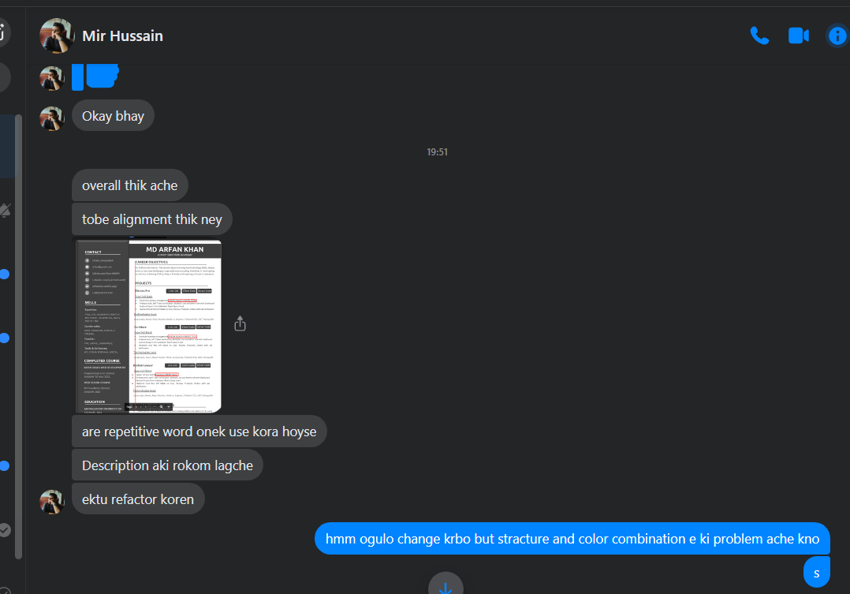

6)Appling Job for react js:

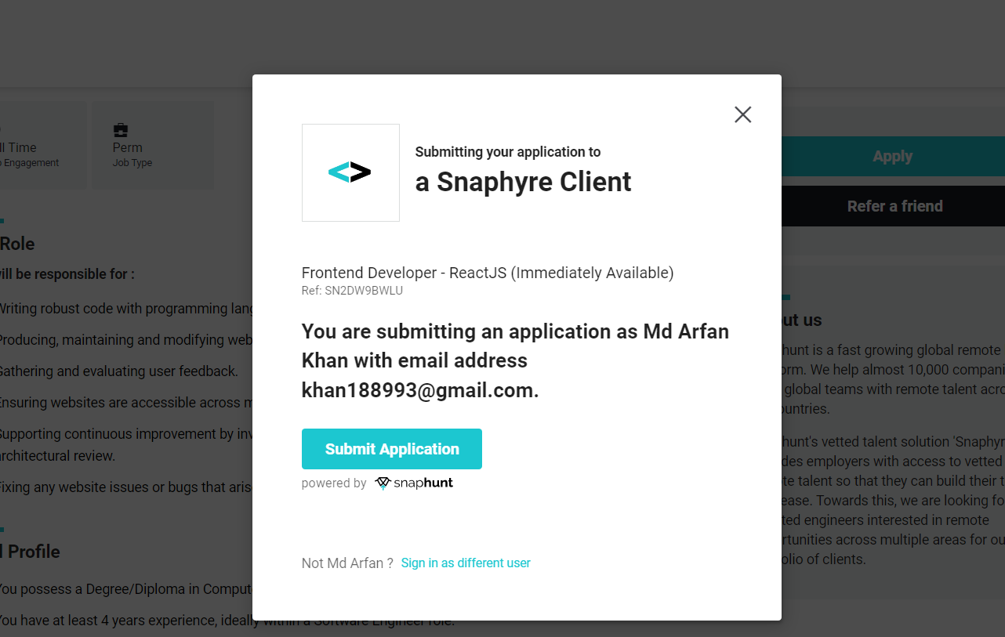

<https://snaphyre.snaphunt.com/job/SN2DW9BWLU-BD-16?source=linkedin>

linked in job post :

https://www.linkedin.com/jobs/search/?currentJobId=3086227521&geoId=106215326&keywords=junior%20react%20developer&location=Bangladesh

